Monday July 20th, analysis of HL results

Model one: simple logistic regression
Model two: OLS of logit of prevalence
Model three: non-bayesian hierarchical model, pooled at the region level

Model 1:
. glm count mage agelgdp aget sex threshold lgdp, family(binomial n)

Iteration 0: log likelihood = -103023.9
Iteration 1: log likelihood = -58696.092
Iteration 2: log likelihood = -56863.544
Iteration 3: log likelihood = -56853.995
Iteration 4: log likelihood = -56853.993

Generalized linear models No. of obs = 1850
Optimization : ML Residual df = 1843
Scale parameter = 1
Deviance = 109570.4402 (1/df) Deviance = 59.45222
Pearson = 595093398.1 (1/df) Pearson = 322893.9

Variance function: V(u) = u*(1-u/n) [Binomial]
Link function : g(u) = ln(u/(n-u)) [Logit]

AIC = 61.47134
Log likelihood = -56853.99323 BIC = 95705.66

------------------------------------------------------------------------------
| OIM
count | Coef. Std. Err. z P>|z| [95% Conf. Interval]
-------------+----------------------------------------------------------------
mage | -.1011097 .0013228 -76.43 0.000 -.1037024 -.0985169
agelgdp | .0104316 .0001403 74.33 0.000 .0101565 .0107067
aget | .0024206 .0000155 156.15 0.000 .0023903 .002451
sex | -.1036113 .010104 -10.25 0.000 -.1234147 -.0838079
threshold | -.284217 .0010427 -272.58 0.000 -.2862607 -.2821734
lgdp | -.5726529 .0079613 -71.93 0.000 -.5882568 -.5570491
_cons | 8.386728 .0780435 107.46 0.000 8.233765 8.53969
------------------------------------------------------------------------------

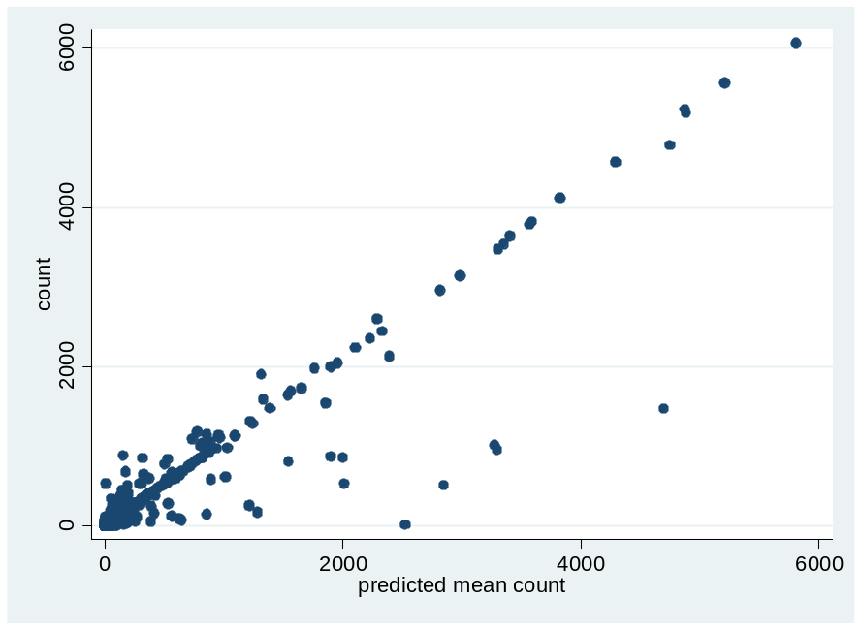
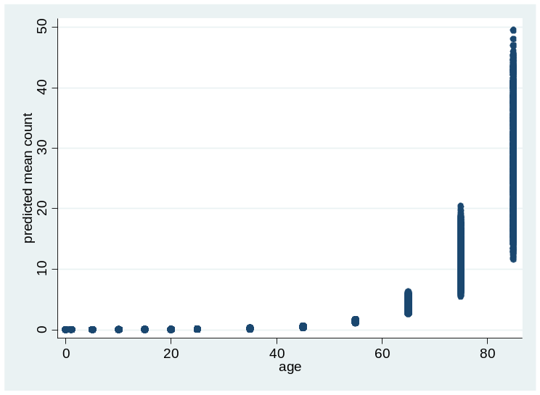

MODEL 2

. regress logitprev mage agelgdp aget sex threshold lgdp if prediction == 0

Source | SS df MS Number of obs = 1850
-------------+------------------------------ F( 6, 1843) = 883.01
Model | 27547.7972 6 4591.29953 Prob > F = 0.0000
Residual | 9582.86366 1843 5.19960047 R-squared = 0.7419
-------------+------------------------------ Adj R-squared = 0.7411
Total | 37130.6609 1849 20.0814823 Root MSE = 2.2803

------------------------------------------------------------------------------
logitprev | Coef. Std. Err. t P>|t| [95% Conf. Interval]
-------------+----------------------------------------------------------------
mage | .0760195 .0150619 5.05 0.000 .0464794 .1055597
agelgdp | -.0010107 .0016369 -0.62 0.537 -.0042211 .0021996
aget | -.000239 .0000685 -3.49 0.001 -.0003735 -.0001046
sex | -.2520804 .1115981 -2.26 0.024 -.4709524 -.0332084
threshold | -.1092001 .0037399 -29.20 0.000 -.116535 -.1018653
lgdp | -.3997273 .0873845 -4.57 0.000 -.5711103 -.2283443
_cons | 3.82677 .792002 4.83 0.000 2.273455 5.380086
------------------------------------------------------------------------------
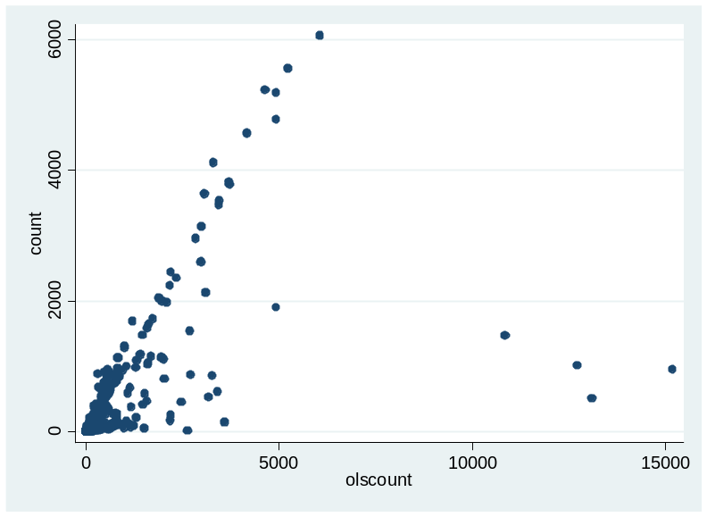

Variable | Obs Mean Std. Dev. Min Max
-------------+--------------------------------------------------------
count | 1850 110.3735 444.3386 0 6063
olscount | 1850 171.931 777.9413 .0006916 15182.94 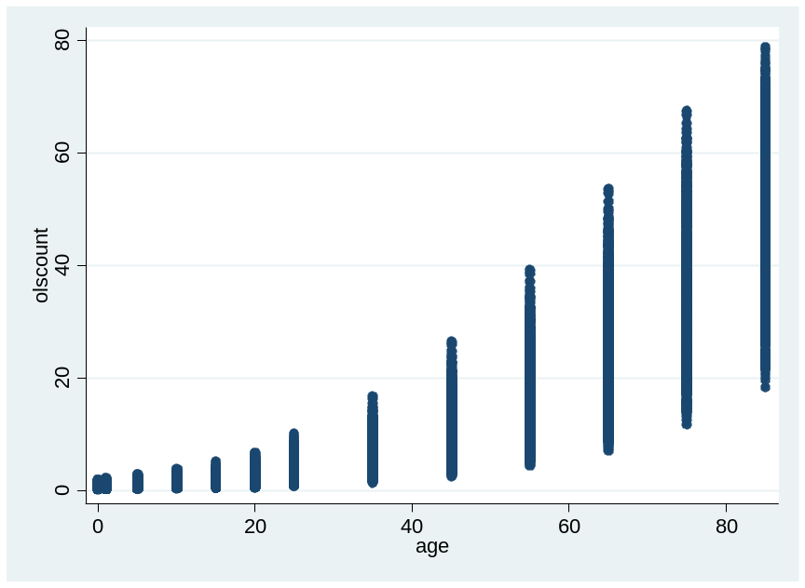

Variable | Obs Mean Std. Dev. Min Max
-------------+--------------------------------------------------------
olscount | 1848 12.43508 21.08001 .0129387 93.89091
simplecount | 1848 4.59896 10.7393 6.32e-07 69.18086
median | 1848 5.741919 9.883743 .0149736 64.27635

